BYOD 2

Aditya kumar

Roll – no -10

Reg no. 12301713

Section- k23XR

**1. User and Group Management**

* **Create a new user account** named "devuser" with the following specifications:
  + Home directory: /home/devuser
  + Shell: /bin/bash
  + Comment: "Developer User"
* **Create a new group** named "developers".
* **Add "devuser" to the "developers" group**.
* **Verify** the user and group setup.  
  *Expected Output:* Should show "devuser" with "developers" in the group list.

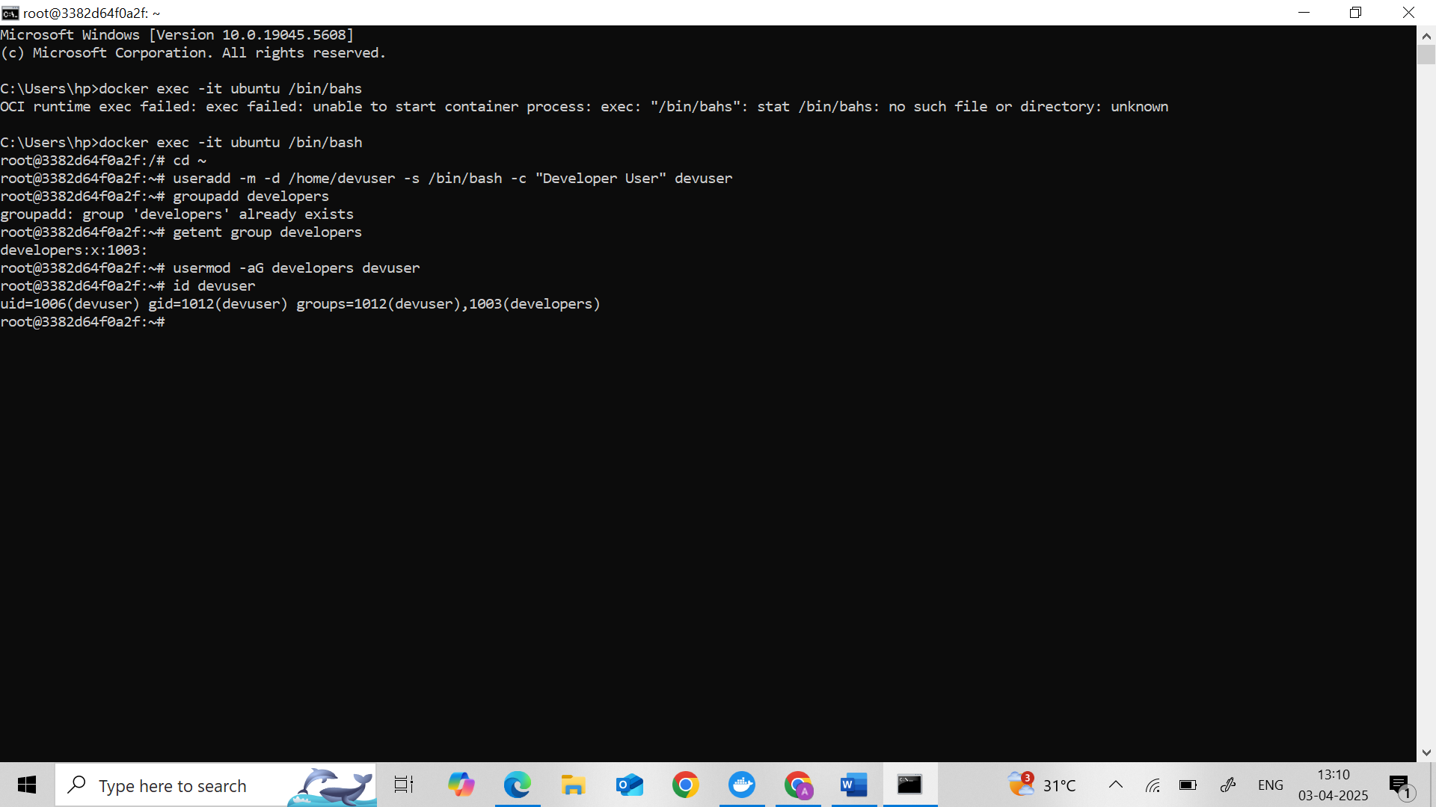

**2. File Permissions**

* **Switch to "devuser"**.
* **Create a directory** named "projects" in the home directory.
* **Set permissions** on "projects" so that:
  + The owner has read, write, and execute permissions (rwx).
  + The group has read and write permissions (rw-).
  + Others have no permissions (---).
* **Verify** the permissions.  
  *Expected Output:* Should show drwxrw---- followed by ownership details.

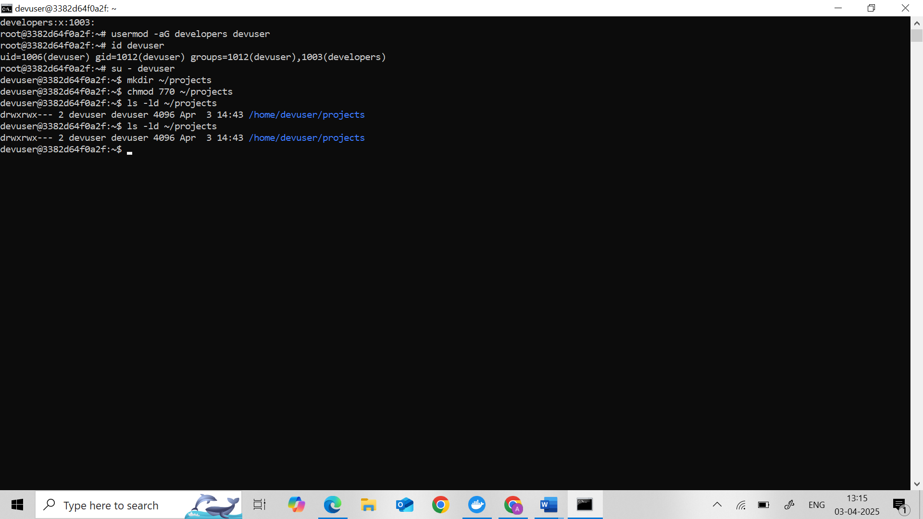

**3. Process Management**

* While logged in as "devuser", **start a background process** using the sleep command for 1000 seconds.
* **List processes** to find the PID of the sleep process.  
  *Expected Output:* Look for "sleep 1000" and note its PID.
* **Terminate the sleep process** using its PID.
* **Confirm** the process is terminated.  
  *Expected Output:* "sleep 1000" should no longer appear in the process list.

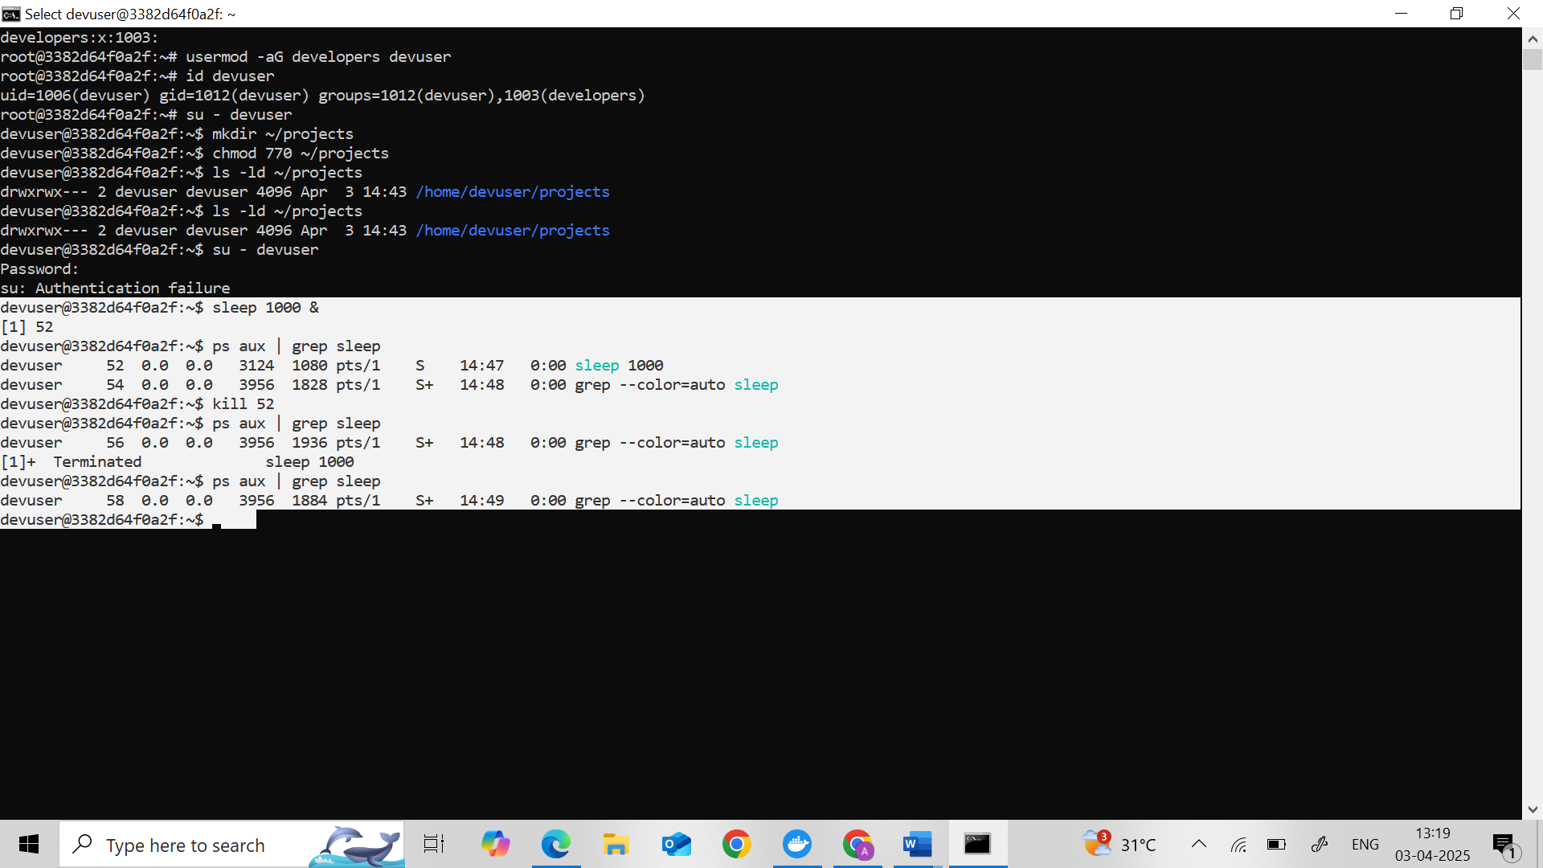

**4. Task Scheduling**

* As "devuser", **create a script** named "hello.sh" in the "projects" directory with the following content:

bash

#!/bin/bash

echo "Hello, World!"

* **Make the script executable**.
* **Schedule a cron job** to run the script every minute.

**Verify** the script runs (wait 1 minute).  
*Hint:* You may check system logs or look for output manually

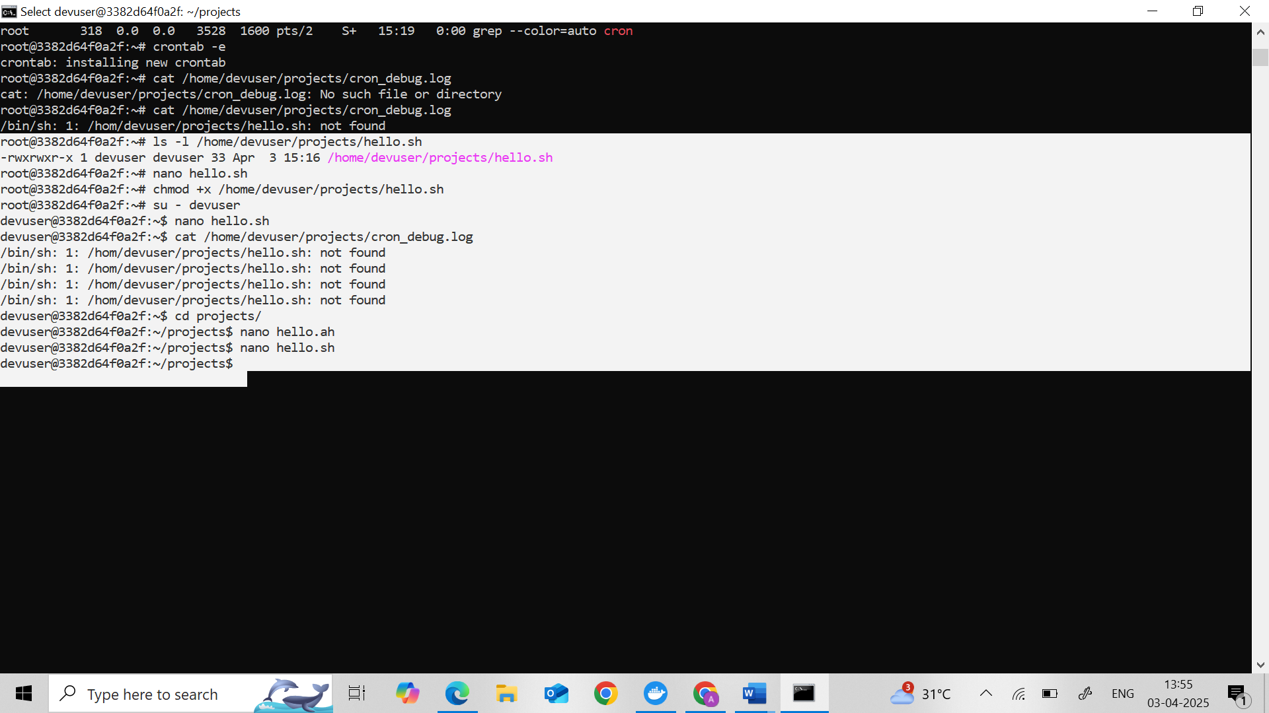

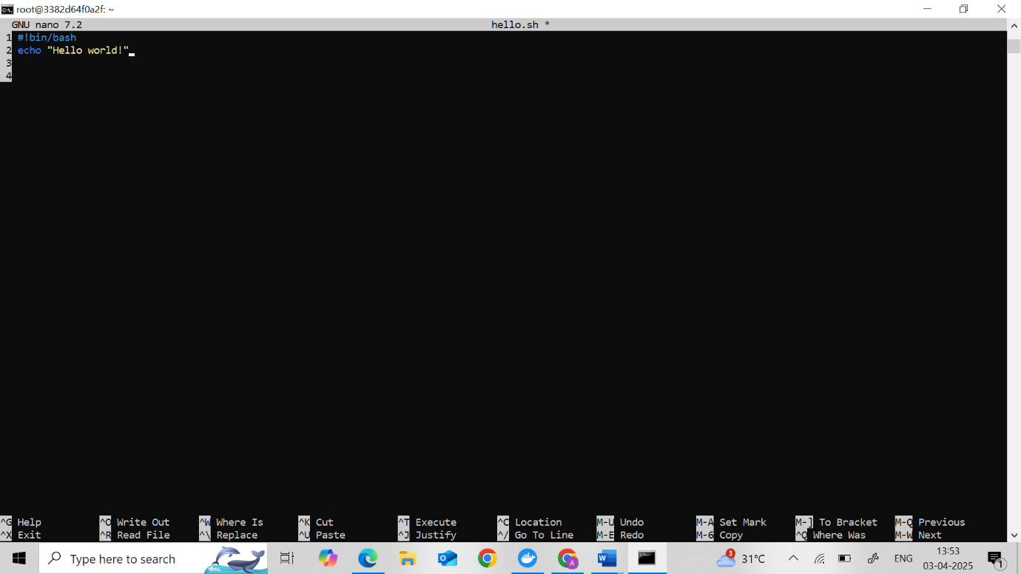

**5. Resource Monitoring**

* **Exit back to your original user**.
* **Check memory usage**.  
  *Action:* Note the "used" and "available" memory values.
* **Monitor processes**.  
  *Action:* Observe for a few seconds, then exit the monitoring tool.

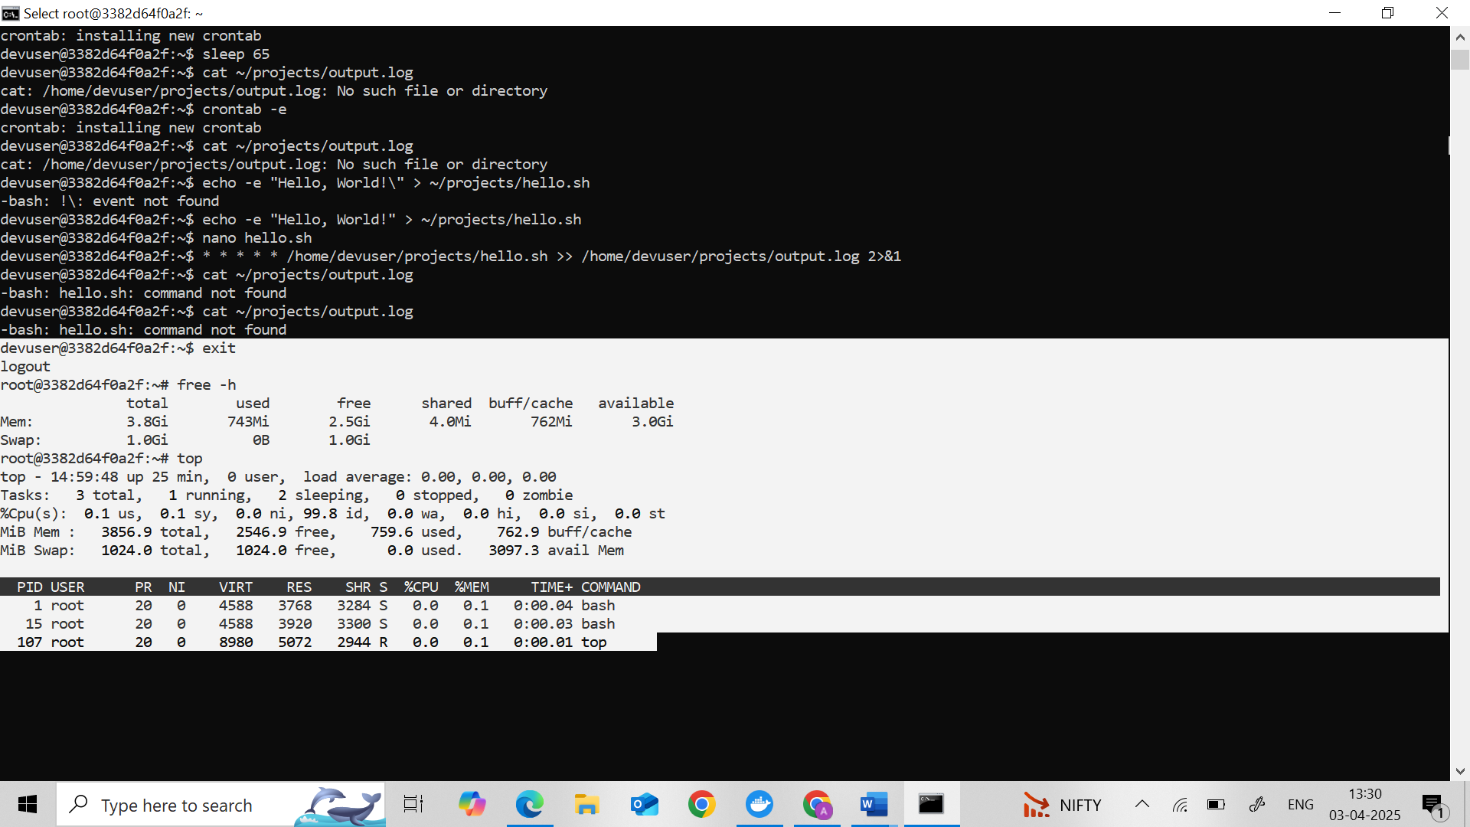

**6. Package Management**

* **Install the "htop" package**.
* **Run "htop"** to monitor resources briefly.  
  *Action:* Explore the interface, then exit.

**Remove the "htop" package**

